ACTIVITY 2 (workshop version)
Scientiﬁc Revolution: General Relativity

Scientiﬁc models must make predictions that match our observations, or they must be revised or replaced. New scientiﬁc models can be revolutionary. In this activity you are going to examine two models of gravity: Newton’s classical force model, and Einstein’s revolutionary curved spacetime model.

Part A: Modeling Gravity

Complete this table after watching >>Alice & Bob in Wonderland: What Keeps Us Stuck to Earth?

 | Force Model | Acceleration Model
Gravity: How does it work?

What’s hard to accept?

Alice steps  off the top of  a tall ladder and falls to the bottom  Bob stands  at the bottom  of the ladder | In the boxes, sketch snapshots of Alice as she falls to the ground and Bob as he stands at the bottom  of the ladder, showing their progression in time. [Hint: Alice moves faster and faster as she falls.]  Connect-the-dots of Alice’s position in SPACE (height above the ground) as TIME goes on. Is her path through spacetime straight or curved?  Connect-the-dots of Bob’s position in SPACE (height above the ground) as TIME goes on. Is Bob’s path through spacetime straight or curved? | 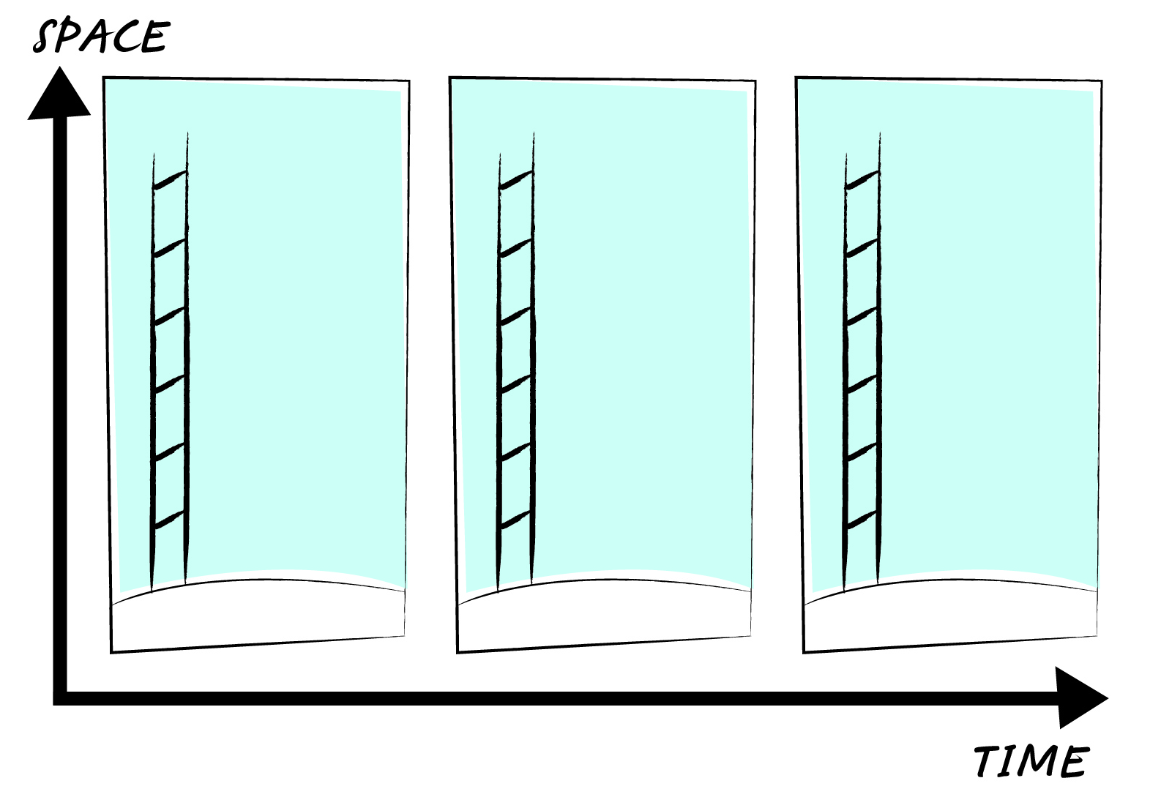
According to  Newton... | Alice’s path through spacetime is ______________ because she is accelerating. She is accelerating because gravity is  (straight/curved)  a force pulling on her. Bob’s path through spacetime is _______________ because he is not accelerating—the force of  (straight/curved)  gravity is balanced by the ground pushing up.
According to  Einstein... | There is no “force of gravity” pulling down on Alice so she ________ accelerating. Her path through spacetime should  (is/is not)  be __________________. The ground pushes up on Bob and since there is no opposing “force of gravity” to balance  (straight/curved)  this force, he should accelerate up and follow a _________________ path through spacetime.
 | (straight/curved)

Discussion

1. Alice has a video camera in her hands as she falls. If she takes a video of herself as she falls, could she tell that she was
accelerating by viewing the video? (Ignore the background.)
2. Alice takes a video of Bob as she falls. Could she tell who was accelerating by viewing the video? (Ignore the background.)
3. Alice closes her eyes as she falls. What does she feel? Can she tell that she is accelerating?
4. Bob closes his eyes. What does he feel? Can he interpret this feeling as accelerating up?

Einstein knew that Newton’s model of gravity is wrong. For one thing, it fails to correctly predict the orbit of Mercury; for
another, it fails to obey the speed limit of the universe—the speed of light. In his search for a better model, the simple
fact that acceleration up mimics force down was too strong of a coincidence to ignore. Einstein needed to ﬁnd a way to
make sense of the ground accelerating up without moving up. How can the ground be accelerating up when Earth is not
expanding? He found the answer in the geometry of spacetime.

Part B: Bending Spacetime

In Part A, we used the fact that accelerating objects trace out curved paths in spacetime and non-accelerating objects
trace out straight paths. We also saw that Newton and Einstein would disagree on who is accelerating and who is not. In
this part of the activity you will use tape to transfer the spacetime diagram from Part A onto the surface of a large ball to
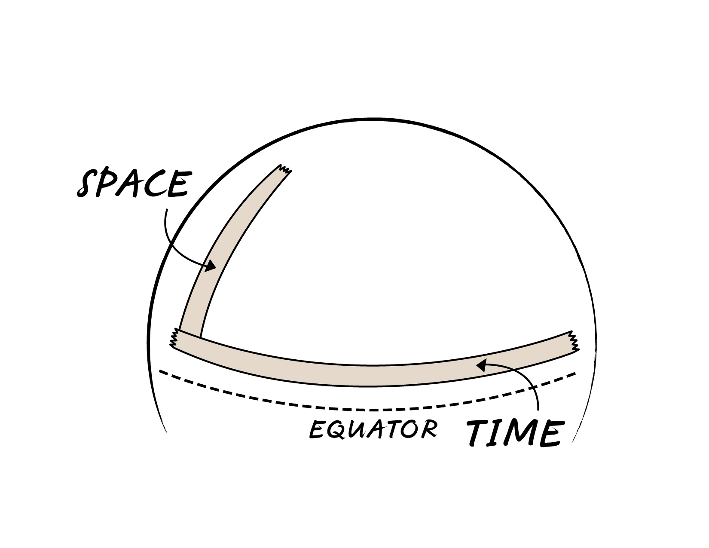
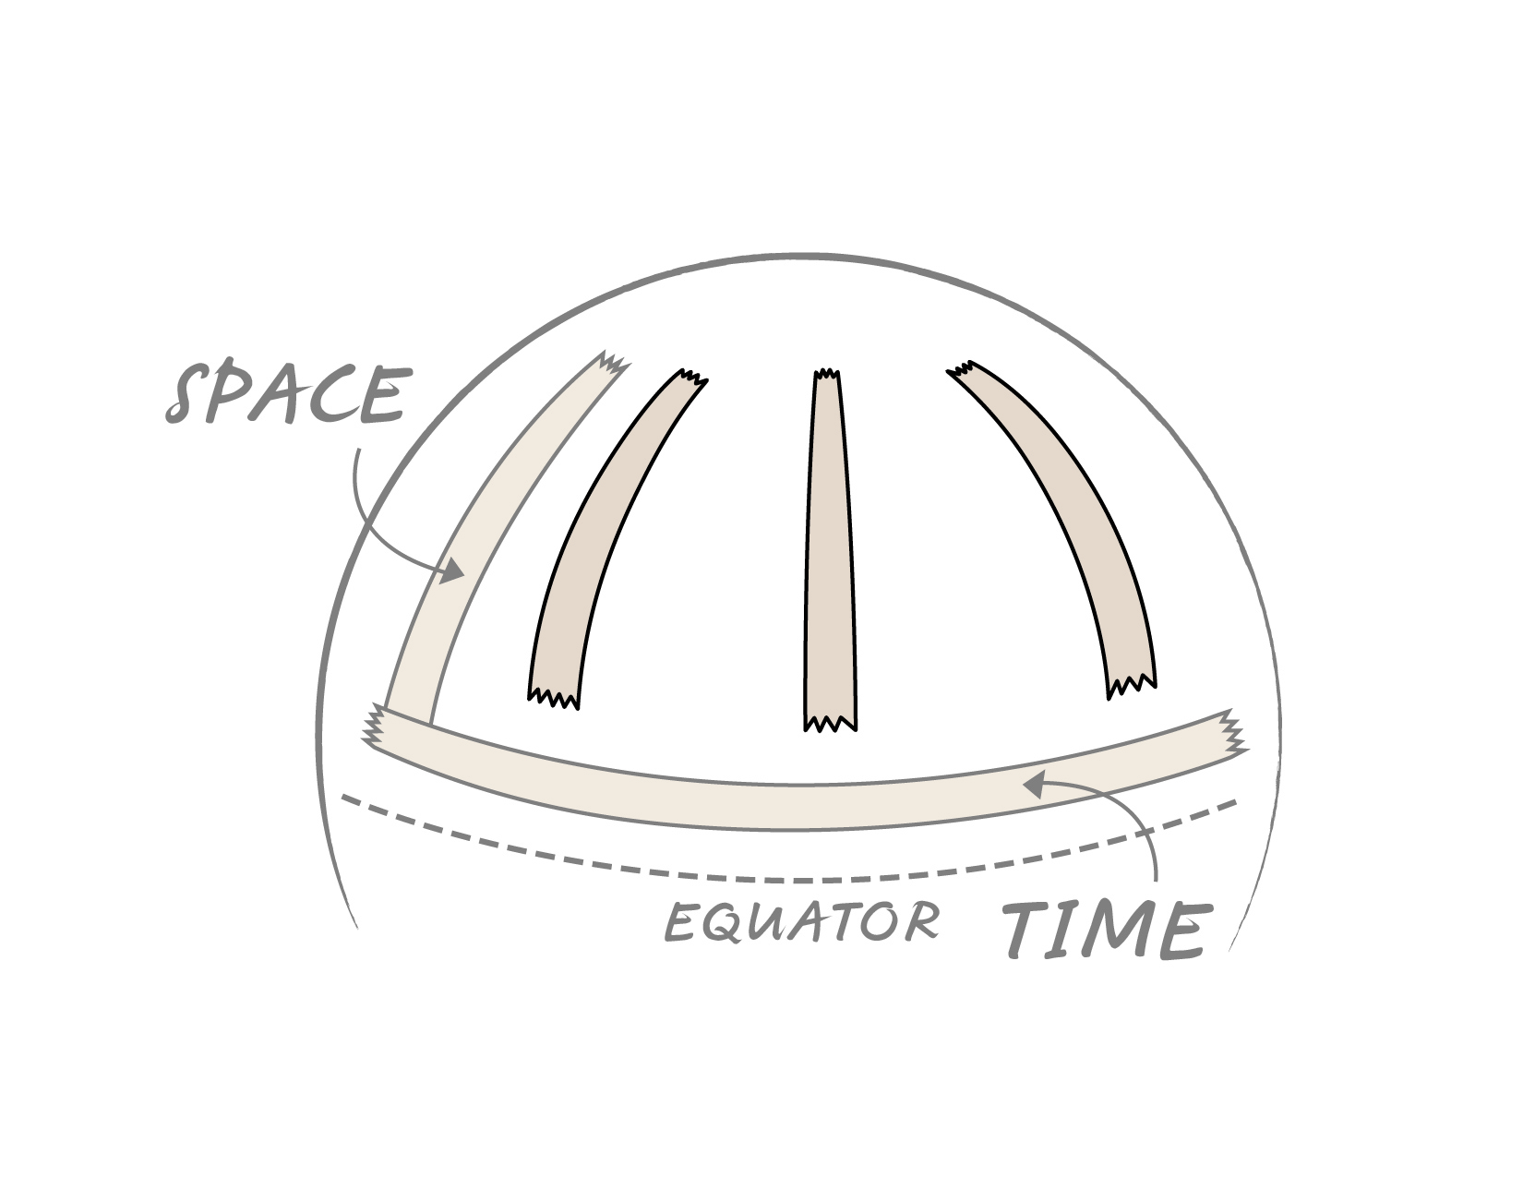
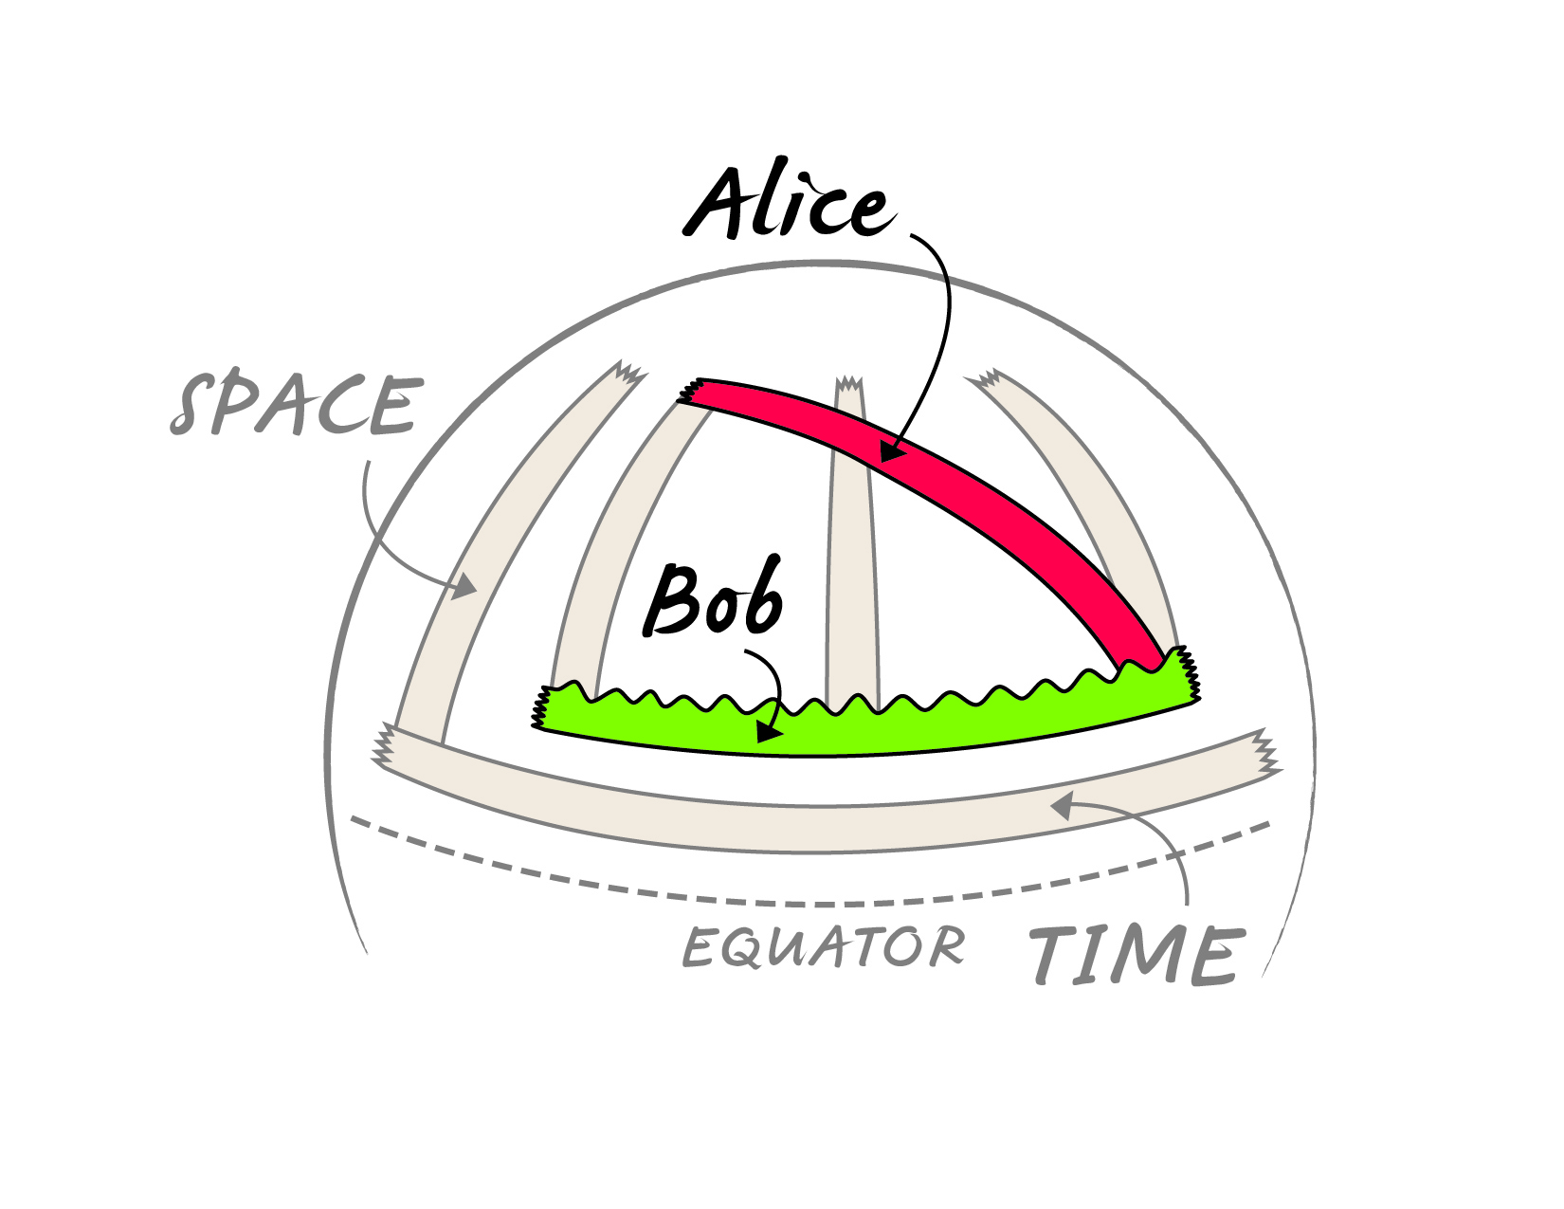
reveal how curving spacetime makes Einstein’s idea of who is accelerating make sense.

1. Use strips of tape to transfer the spacetime diagram from Part A onto the ﬂat surface of your desk.
Compare Alice’s and Bob’s paths. Which strip of tape lies ﬂat on the desk and which is crinkled?

2. Build your spacetime diagram on the surface of a large ball. Start with the space and time axes.
• The space axis is a strip of tape that runs vertically along a line of longitude (see top Figure).
• The time axis runs horizontally along a circle of latitude (about 15˚ above the equator).

3. Add three identical strips of tape to represent the ladder in three consecutive snapshots. The ladders
must follow lines of longitude on the surface, starting about 2 cm above the time axis and ending
about 10 cm from the top.

4. Alice’s path is a strip of tape that connects the top of the ﬁrst ladder with the bottom of the last ladder.
Can you make it a straight line? Why would you want to?

5. Bob’s path runs parallel to the time axis along a circle of latitude. It will connect the bottoms of the
three ladders. Does the tape lie ﬂat or is it crinkled? What does this indicate?

Curved Spacetime | When we transfer the spacetime diagram to the ball we ﬁnd that the tape for Alice’s path is_______________, which  (flat/crinkled)  means the line is ________________ so Alice is ________________________ through curved spacetime. The tape  (straight/curved) (accelerating/not accelerating)  describing Bob’s path is_____________, which means the line is ______________ so Bob is__________________  (flat/crinkled) (straight/curved) (accelerating/not accelerating)  through curved spacetime. Drawing the spacetime diagram on a curved surface reverses who is accelerating and who is not—just what Einstein needed to make the acceleration model make sense. The ground can be forever accelerating up without moving up! Gravity is not a force—it is curved spacetime.

6. The time elapsed for Bob at the bottom of the ladder is the length of his path (i.e. distance in the time direction). If Alice stayed
at the top of the ladder, would her elapsed time be the same? Einstein’s model predicts time dilation: time passes at different
rates depending on height about the ground, which has been veriﬁed by atomic clocks. Newton’s model predicts there should
be no time dilation, which is wrong. Models cannot be proven right—but they can be proven wrong and time dilation proves
that Newton’s model of gravity is wrong!

Evaluating Models | Newton’s model fails to predict the orbit of Mercury accurately. Einstein’s model does and it also accurately predicts time dilation and the bending of light. We must conclude that the best model of  gravity is _____________________ _________________________ model.  (Newton’s/Einstein’s) (force/curved spacetime)

By curving spacetime, Alice’s path changes from curved to straight—she experiences no “force of gravity” and no acceleration. By curving spacetime, Bob’s path changes from straight to curved—he experiences the ground pushing up on him, continually accelerating him up, but without him moving up. Einstein was able to show that gravity is not a mysterious, invisible force—it is the curvature of spacetime. This curved spacetime model asserts that you feel heavy because the surface of Earth is forever accelerating up without actually moving up.

